Texas Workforce Commission

*ADA Monitoring Checklist for Texas Workforce Facilities*

  

*Based on the 2012 Texas Accessibility Standards (TAS)*



The checklist as presented was modified as allowed by the authors to represent standards of the 2012 Texas Accessibility Standards (TAS), Elimination of Architectural Barriers, Texas Government Code, Chapter 469, administered by the Texas Department of Licensing and Regulation (TDLR). The TDLR received equivalency certification from the U.S. Department of Justice that the TAS, including the appendix and Architectural Barriers Administrative Rules Chapter 68, met or exceeded the new construction and alteration requirements for the ADA and are consistent with the ADA Accessibility Guidelines.

**ADA Checklist for 2012 Texas**

**Accessibility Standards (TAS)**

The Americans with Disabilities Act (ADA) requires state and local governments, businesses and non-profit organizations to provide goods, services and programs to people with disabilities on an equal basis with the rest of the public.

Some people think that only new construction and alterations need to be accessible and that older facilities are “grandfathered,” but that’s not true. Because the ADA is a civil rights law and not a building code, older facilities are often required to be accessible to ensure that people with disabilities have an equal opportunity to participate.

The ADA has different requirements for state and local governments and for places of public accommodation (businesses and non-profit organizations that serve the public).

**Requirements for State and Local Governments**

State and local governments must ensure that services, programs and activities, when viewed in their entirety, are accessible to people with disabilities. This is part of public entities’ program accessibility obligations. Alterations to older buildings may be needed to ensure program accessibility. Generally this is a greater obligation than “readily achievable barrier removal” the standard that applies to public accommodations. State and local governments are not required to take any action that would result in undue financial and administrative burdens.

**How to Use this**

**Checklist**

**Get Organized**

One person can conduct a survey, but it’s easier with two people. One person can take measurements and the other person can fill out the checklist and take photos.

**Obtain Floor Plan or Make Sketch**

A floor plan or sketch helps the surveyors to get organized and to know how many elements there are, such as drinking fountains, entrances and toilet rooms, and where they are located. If plans are not available, sketch the layout of interior and exterior spaces and mark the elements on the sketch.

**Make Copies of the Checklist**

Determine how many copies of each section of the checklist you need. For example, most facilities have more than one toilet room.

**Gather Tools**

• Checklist

• Clipboard

• Tape measure

• Electronic or carpenter’s level - 24 inches

• Door pressure gauge or fish scale for measuring door-opening force

• Digital camera

• Bag to hold these items

State and local governments’ ADA obligations for program accessibility are in the Department of Justice’s ADA Title II regulations 28 CFR Part 35.150 and Texas Government Code, Chapter 469.

**Requirements for Places of Public Accommodation** Businesses and non-profit organizations that serve the public must remove architectural barriers when it is “readily achievable” to do so; in other words, when barrier removal is “easily accomplishable and able to be carried out without much difficulty or expense.”

The decision of what is readily achievable is made considering the size, type, and overall finances of the public accommodation and the nature and cost of the access improvements needed. Barrier removal that is difficult now may be readily achievable in the future as finances change.

Public accommodations’ ADA obligations for barrier removal are in the Department of

Justice’s ADA Title III regulations 28 CFR Part 36.304.

**Priorities for Accessibility**

The checklist follows the four priorities that are listed in the Department of Justice ADA Title III regulations. These priorities are equally applicable to state and local government facilities.

Priority 1 - Accessible approach and entrance Priority 2 - Access to goods and services Priority 3 - Access to public toilet rooms

Priority 4 - Access to other items such as water fountains and public telephones

**Conduct the Survey**

**Start Outside**

Start from site arrival points such as drop-off areas and public sidewalks and determine if there is an accessible route to an accessible entrance. If there is a parking lot or garage check for the correct number of accessible

parking spaces, including van-accessible spaces. Is there an accessible route from the accessible

parking spaces to an accessible entrance? Next

survey the entrances. If there is an accessible entrance, determine if there are signs at inaccessible entrances directing people to the

accessible entrance. Go inside and continue through the facility and the checklist.

**Keep Good Notes**

Write on the front of each checklist where you are surveying. You may end up with six toilet room checklists. When you get back to your office you’ll want to know which one is the checklist for the first floor women’s room. If there isn’t an accessible entrance you’ll want to indicate how many steps there are and how much space is available to install a ramp or lift. This is a good time to take photographs.

**Take Good Measurements**

When in doubt write it down. It’s better to have too much information than not enough. Even if something is in compliance it’s helpful to have exact measurements.

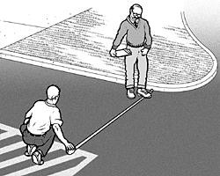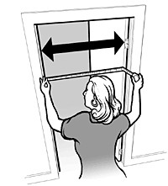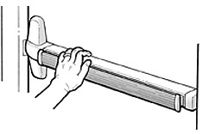

**2010 ADA Standards for Accessible Design**

The checklist is based on the 2010 ADA Standards for Accessible Design (2010

Standards). The checklist does not include all sections of the 2010 Standards. Full compliance with the 2010 Standards is required only for new construction and alterations.

**Safe Harbor – Construction Prior to March 15, 2012**

Elements in facilities built or altered before March 15, 2012 that comply with the 1991

ADA Standards for Accessible Design (1991 Standards) are not required to be modified to specifications in the 2010 Standards. For example, the 1991 Standards allow 54 inches maximum for a side reach range to a control such as the operating part of a paper towel dispenser. The 2010 Standards lower that side reach range to 48 inches maximum. If a paper towel dispenser was installed prior to March 15, 2012 with the highest operating part at 54 inches, the paper towel dispenser does not need to be lowered to 48 inches.

**Elements in the 2010 Standards that aren’t in the 1991**

**Standards**

The 2010 Standards contain elements that are not in the 1991 Standards*.* These elements include recreation facilities such as swimming pools, team and player seating, accessible routes to court sports facilities, saunas and steam rooms, fishing piers, play areas, exercise machines, golf facilities, miniature golf facilities, amusement rides, shooting facilities with firing positions, and recreational boating facilities. Because these elements are not in the 1991 Standards, they are not subject to the safe harbor exemption. State and local governments must make these items

**Parking Spaces**

Measure from the center of marking lines. If lines are not adjacent to another space or aisle, the measurement can be to the full width of the line.

**Door Clear Width**

Open the door 90 degrees, measure from the face of the door to the edge of the

door stop**.**

**Door Opening Force** If you’re using a door pressure gauge place it where you would push open the door.

accessible if necessary to ensure program accessibility, unless an undue burden would result. Public accommodations must remove architectural barriers to these items.

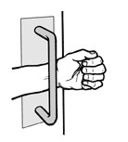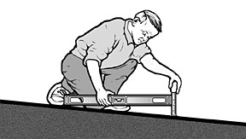

**What this Checklist is Not**

The ADA Title II and III regulations require more than program accessibility and barrier removal. The regulations include requirements for nondiscriminatory policies and practices and for the provision of auxiliary aids and services, such as sign language interpreters for people who are deaf and material in Braille for people who are blind. This checklist does not cover those requirements.

Since this checklist does not include all of the 2010 Standards it is not intended to determine compliance for new construction or facilities being altered.

**What are Public Accommodations?**

Under the ADA public accommodations are private entities that own, lease, lease to or operate a place of public accommodation. This means that both a landlord who leases space in a building to a tenant and the tenant who operates a place of public accommodation have responsibilities to remove barriers.

A place of public accommodation is a facility whose operations affect commerce and fall within at least one of the following 12 categories:

1) Places of lodging (e.g., inns, hotels, motels, except for owner-occupied establishments renting fewer than six rooms)

2) Establishments serving food or drink (e.g. , restaurants and bars)

3) Places of exhibition or entertainment (e.g., motion picture houses, theaters, concert halls, stadiums)

If you’re using a fish scale, place it where you would pull open the door.

**Accessible Slopes** You can measure slope with 24 inch level and a tape measure. Put the level on the surface in the direction you are

measuring. Put one end at the high point of the surface and raise the other end so that the bubble

is in the middle of the level’s gauge. The level is

now level. Measure the distance between the end of the level at its bottom point and the surface.

For a ramp the maximum running slope allowed is 1:12. That means for every inch of height change there should be at least 12 inches of ramp run. If the distance between the bottom of the level and the ramp surface is 2 inches or

less, then the slope is 1:12 or less (2:24 = 1:12 and 1.5:24 = 1:16 which is a more gradual slope than 1:12). If the distance is greater than 2 inches, the ramp is too steep. For example, if the distance is 3 inches, then the slope is 1:8 (3:24 =

1:8 which is a steeper slope than 1:12).

4) Places of public gathering (e.g. , auditoriums, convention centers, lecture halls)

5) Sales or rental establishments (e.g. , bakeries, grocery stores, hardware stores, shopping centers)

6) Service establishments (e.g. , laundromats, dry-cleaners, banks, barber shops, beauty shops, travel services, shoe repair services, funeral parlors, gas stations, offices of accountants or lawyers, pharmacies, insurance offices, professional offices of health care providers, hospitals)

7) Public transportation terminals, depots, or stations (not including facilities relating to air transportation)

8) Places of public display or collection (e.g. , museums, libraries, galleries)

9) Places of recreation (e.g. , parks, zoos, amusement parks)

10) Places of education (e.g. , nursery schools, elementary, secondary, undergraduate, or postgraduate private schools)

11) Social service center establishments (e.g. , day care centers, senior citizen centers, homeless shelters, food banks, adoption agencies)

12) Places of exercise or recreation (e.g., gymnasiums, health spas, bowling alleys, golf courses).

For the parts of an accessible route that aren’t a

ramp, the maximum running slope allowed is

1:20. That means for every inch of height

change there must be at least 20 inches of route run. The distance from the bottom edge of the

level to the surface should be no more than 1.2 inches (1.2:24 = 1:20).

For the cross slope of an accessible route the maximum slope allowed is 1:48. The distance from the bottom edge of the level to the surface should be no more than ½ inch (.5:24 = 1:48). The cross slope of an accessible route is the slope that is perpendicular to the direction of pedestrian travel.

Slopes may also be measured using a **digital level**. Be sure to read the instructions. Measure with the percent calculation rather than the degrees calculation. For a ramp the maximum running slope allowed is 8.33% (8.33% is a 1:12 slope). For an accessible route without a ramp the maximum running slope allowed is 5% (1:20). For the cross slope of an accessible route the maximum slope allowed is 2.083% (1:48).

**Check that You Got Everything**

Before you leave the site review all the checklists. Make sure you know which checklist goes with which entrance and which toilet room and that you’ve got all the information you need. It is better to do it now than to have to go back.

**Resources**

**U.S. Department of Justice ADA Information**

800-514-0301 voice

800-514-0383 TTY

[www.ada.gov](http://www.ada.gov/)

**ADA National Network**

800-949-4232 voice/TTY connects to your regional ADA Center

[www.adata.org](http://www.adata.org/)

**U.S. Access Board**

800- 872-2253 voice

800-993-2822 TTY

[www.access-board.gov](http://www.access-board.gov/)

**ADA Title II Regulations 28 CFR Part 35**

[www.ada.gov/regs2010/titleII_2010/titleII_2010_regulations.htm](http://www.ada.gov/regs2010/titleII_2010/titleII_2010_regulations.htm)

[**ADA Title III Regulations 28 CFR Part 36**](http://www.ada.gov/regs2010/titleIII_2010/titleIII_2010_regulations.htm)

[www.ada.gov/regs2010/titleIII_2010/titleIII_2010_regulations.htm](http://www.ada.gov/regs2010/titleIII_2010/titleIII_2010_regulations.htm)

[**2010 ADA Standards for Accessible Design**](http://www.ada.gov/2010ADAstandards_index.htm)

[www.ada.gov/regs2010/2010ADAStandards/2010ADAstandards.htm](https://www.ada.gov/regs2010/2010ADAStandards/2010ADAstandards.htm)

**2012 Texas Accessibility Standards (TAS)**

[www.tdlr.texas.gov/ab/2012TAS/2012tascomplete.pdf](https://www.tdlr.texas.gov/ab/2012TAS/2012tascomplete.pdf)

[**1991 ADA Standards for Accessible Design**](http://www.ada.gov/2010ADAstandards_index.htm)

[www.ada.gov/1991standards/1991standards-archive.html](http://www.ada.gov/1991standards/1991standards-archive.html)

**1994 Architectural Barrier Texas Accessibility Standards (TAS)**

[www.tdlr.texas.gov/ab/1994abtas.htm](http://www.tdlr.texas.gov/ab/1994abtas.htm)

**After the Survey**

**List Barriers and Solutions**

Consider the solutions listed beside each question on the checklist and add your own ideas. Consult with building contractors and equipment suppliers to estimate the costs for making modifications.

**Develop an Implementation Plan** State and local governments were required to develop a Transition Plan a few years after the

ADA went into effect. Conducting a current survey

is a good opportunity to update the plan.

Although places of public accommodation are not required to have a plan, the Department of Justice recommends one: *"...Such a plan...could serve as evidence of a good faith effort to comply..."*

Prioritize items, make a timeline, decide who is responsible to carry out the plan, and develop a budget.

**Make Changes**

Use the 2012 Texas Accessibility Standards (TAS). Check whether local and state building codes require greater accessibility when alterations are undertaken.

**Follow Up**

Review the plan each year to evaluate whether more access improvements can be made.

***Acknowledgements:***

**Tax Deductions and Credits for Barrier Removal**

[www.ada.gov/taxincent.htm](http://www.ada.gov/taxincent.htm)

*Many of the illustrations are from the U.S. Department of Justice and the U.S. Access Board or are based on illustrations produced by the U.S. Access Board and the U.S. Department of Justice. Other photographs come from U.S. Access Board webinars and from actual physical accessibility reviews conducted at local Texas workforce centers.*

**ADA Checklist for 2012 Texas Accessibility Standards (TAS)**

**Priority 1 – Accessible Approach and Entrance**

**Name of Board: Site/Center Name: Physical Address: Date:**

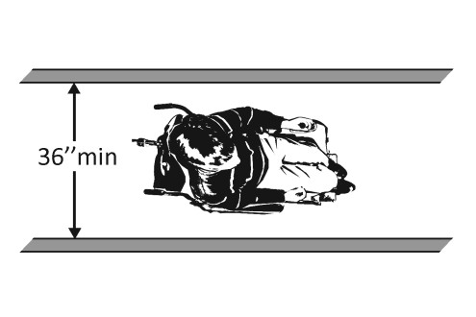

**Reviewer:**

**Contact Information:**

**An accessible route from site arrival points and an accessible entrance should be provided for everyone.**

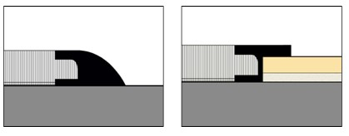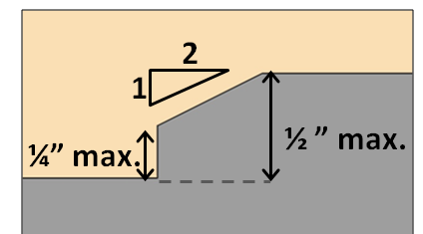

|  |  |  |  |  |  |
| --- | --- | --- | --- | --- | --- |
| **Priority 1 – Accessible Approach and Entrance** | | |  | **Comments** | **Possible Solutions** |
| **1.1**  **TAS**  **206.2.1**  **303.4**  **402**  **403**  **404** | Is there at least one accessible route from site arrival points (parking, passenger loading zones, public streets and sidewalks, and public transportation stops) to the facility’s accessible entrance? | □Yes □No □N/A  If yes, location of route: |  | Photo #: | • Add a ramp  • Regrade to 1:20 maximum slope  • Add a lift if site constraints  prevent other solutions |
| **1.2**  **TAS**  **303.4**  **402**  **403**  **404** | Is there an accessible route to the accessible entrance with a walking surface that does not include a change in level (i.e., stairs, steps or escalators)  *or*  are any changes in level greater  than 1/4” to 1/2” beveled  *or*  are any changes in level greater  than 1/2” ramped? | □Yes □No □N/A  If yes, location on route:  □Yes □No □N/A  □Yes □No □N/A | 1/2” max height, 1/4” max high  1:2 max beveled edge vertical edge  permitted | Photo #: | • Create accessible route  • Repair/adjust level changes in walking surface |
| **1.3**  **TAS**  **206.4.1**  **404** | Are 60% of all public entrances accessible?*  Definitions:  *Public Entrance* – not a service or a restricted entrance.  *Restricted Entrance* – Common use on a controlled basis but not a public use and/or service entrance.  *Service Entrance* – Intended primarily for delivery of goods or services. | □Yes □No □N/A  Total # public entrances: |  | Photo #: | *If constructed before  3/15/2012, entrances are compliant if 50% of entrances are accessible |

|  |  |  |  |  |  |
| --- | --- | --- | --- | --- | --- |
| **PARKING** *(2012 Standards – TAS Chapters 2 (208) and 5 (502))* **Note: Accessible parking spaces should be identified by size, access aisle and signage.** | | | | | |
| **1.4** If parking is provided for the  **TAS** public, are an adequate number  **208.2** of accessible spaces provided for the designated workforce center location? | □Yes □No □N/A  Total #: Accessible #: | **Total Spaces** | **Accessible**  **Spaces** | Photo #: | • Reconfigure by repainting lines |
| 1 - 25 | 1 |
| 26 - 50 | 2 |
| 51 - 75 | 3 |
| 76 - 100 | 4 |
| 100+ see 2010 Standards 208.2 | |
| **1.5** • Are accessible spaces marked  **TAS** with a sign containing the  **502.6** International Symbol of  Accessibility?  • Is the bottom of the sign at least 60” above the ground? | □Yes □No □N/A  □Yes □No □N/A  Measurement: |  | | Photo #: | • Install missing signs  • Replace faded signs  • Re-mount low signs Accessibility Symbol not required on ground by 2012  TAS. |
| **1.6** Of the accessible spaces, is at  **TAS** least one space designated a  **208.2.4** van accessible space?* | □Yes □No □N/A    | *For every 6 or fraction of 6 parking spaces required by the table above, at least 1 should be a van accessible space. | | Photo #: | * If constructed before 3/15/12, parking is compliant if 1 in 8 accessible spaces is van accessible |
| **1.7** Is there at least one “van  **TAS** accessible” space with the sign:  **502.6** • mounted vertically at least  60” above ground surface;  • showing the international symbol of accessibility; and  • “van accessible” is posted below the accessibility icon? | □Yes □No □N/A    |  | | Photo #: | • Install missing signs  • Re-mount low signs |
| **1.8** Are accessible spaces at least 96”  **TAS** (8 feet) wide and have an access  **502.2** aisle* at least 60” (5 feet) wide?  **502.3.1** | □Yes □No □N/A  Measurements: Space: Aisle: |  | | Photo #: | • Reconfigure by repainting lines  *Two spaces can share an access aisle (TAS 502.3) |

|  |  |  |  |  |
| --- | --- | --- | --- | --- |
| **1.9** Is the van accessible space:  **TAS** • at least 132” (11 feet) wide  **502.2** with an access aisle at least  **502.3.1** 60” (5 feet) wide  *or*  • at least 96” (8 feet) wide with  an access aisle at least 96” (8 feet) wide? | □Yes □No □N/A     Measurement:  □Yes □No □N/A  Measurement: |  | Photo #: | • Reconfigure to provide van- accessible space(s) |
| **1.11** Are accessible parking spaces on  **TAS** the shortest accessible route of  **208.3.1** travel from parking facilities to the accessible public entrance? | □Yes □No □N/A    |  | Photo: | • Relocate accessible spaces  • Reconfigure spaces |
| **1.12** Are the access aisles marked so  **TAS** as to discourage parking in  **502.3.3** them? | □Yes □No □N/A    |  | Photo #: | • Mark access aisles  The marking method and color may be addressed by state/local requirements |
| **1.13** Does the access aisle extend the  **TAS** full length of the parking spaces  **502.3.2** they serve? | □Yes □No □N/A  Measurement:  |  | Photo #: | • Adjust access aisles |
| **1.14** Do the access aisles next to  **TAS** accessible parking spaces adjoin  **502.3** the closest accessible route to the accessible entrance?  ***Advisory 502.3*** - Access Aisle: Accessible routes must connect parking spaces to accessible entrances. Travel behind parked cars is no longer prohibited but the advisory note states it is preferable the accessible route not pass behind parked cars. | □Yes □No □N/A    |  | Photo #: | • Create accessible route  • Relocate accessible space  • Reconfigure spaces  If parking lot serves multiple entrances, accessible spaces should be dispersed. |

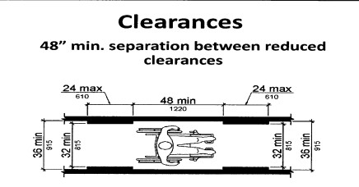

|  |  |  |  |  |  |
| --- | --- | --- | --- | --- | --- |
| **EXTERIOR ACCESSIBLE ROUTE AND WALKING SURFACES** *(2012 TAS Standards–302 and 403))* **Note: Portions of an accessible route steeper than 1:20 are treated as a ramp.** | | | | | |
| **1.15** Is the route stable, firm and slip-  **TAS** resistant?  **302.1** | □Yes □No □N/A |  | Photo #: | • Repair uneven paving  • Fill small bumps and breaks with patches  • Replace gravel with asphalt or other surface | |
| **1.16** Is the route at least 36” wide?  **TAS *Note***: The accessible route can narrow  **403.5.1** to 32” minimum for a run up to 24” long. These narrower portions of the route must be at least 48 inches from  each other. | □Yes □No □N/A  Measurement: |  | Photo #: | • Change or move landscaping, furnishings or other items  • Widen route | |
| **1.17** • If there are grates or openings  **TAS** on the route, are the openings  **302.3** no larger than 1/2” to the dominant direction of travel?  • Is the long dimension perpendicular to the dominant direction of travel? | □Yes □No □N/A  Measurement:  □Yes □No □N/A |  | Photo #: | • Replace or move grate | |
| **Ramps and Curb Ramps** *(2012 TAS Standards – Chapters 4 (403, 405 and 406) and 5 (505))* **Note: Any portion of an accessible route steeper than 1:20 should be treated as a ramp.** | | | | | |
| **1.18** If there are changes in level on  **TAS** the exterior accessible route, is  **403.3** the running slope no steeper than 1:20 (5% slope/grade), i.e. for every 1” of height change there are at 20” of route run? | □Yes □No □N/A  Measurement: |  | Photo #: | | • Regrade to 1:20 (5%) max  • If steeper than 1:20 and no steeper than 1:12 (8.33%), treat as a ramp and add other features such as edge protection and handrails |

|  |  |  |  |  |
| --- | --- | --- | --- | --- |
| **1.19** Is the cross slope of the  **TAS** exterior accessible route no  **403.3** steeper than 1:48 (2%  slope/grade)? | □Yes □No □N/A  Measurement: |  | Photo #: | • Regrade to 1:48 (2%) max |
| **1.20** Is there a curb ramp if the  **TAS** accessible route crosses a  **406.1** curb? | □Yes □No □N/A |  | Photo #: | • Install curb ramp |
| **1.21** Is the running slope of the curb  **TAS** ramp no steeper than 1:12  **405.2** (8.33% slope/grade), i.e., for every 1 inch of height change there are at least 12” of curb ramp run? | □Yes □No □N/A  Measurement: |  | Photo #: | • Regrade curb ramp |
| **1.22** • If there is a ramp (other than  **TAS** curb ramps), is it at least 36”  **405.5** wide?  ***Note***: If there are handrails, measure between handrails.  • Is the surface stable, firm and slip resistant? | □Yes □No □N/A  Measurement:  □Yes □No □N/A |  | Photo #: | • Alter ramp  • Resurface ramp |
| **1.23** For each section of the ramp, is  **TAS** the running slope no greater  **405.2** than 1:12 (8.33%), i.e. for every  1” of height change there are at least 12” of ramp run?  ***Note****:* Rises no greater than 3” with a slope no steeper than 1:8 and rises no greater than 6” with a slope no steeper than 1:10 are permitted if there are space limitations | □Yes □No □N/A  Measurement:  |  | Photo #: | • Alter or relocate ramp  • Lengthen ramp to decrease  slope  • Reconfigure ramp to include switchbacks |

|  |  |  |  |  |
| --- | --- | --- | --- | --- |
| **1.24** Is there a level landing that is  **TAS** at least 60” long and as wide as  **405.7** the ramp:  **405.7.2** • At the top of the ramp?  **405.7.3** • At the bottom of the ramp? |    □Yes □No □N/A  Measurement:  □Yes □No □N/A  Measurement: |  | Photo #: | • Alter ramp  • Relocate ramp |
| **1.25** Where the ramp changes  **TAS** direction, is there a level  **405.7.4** landing at least 60” x 60”? | □Yes □No □N/A  Measurement:  |  | Photo #: | • Alter ramp  • Increase landing size |
| **1.26** If the ramp has a rise higher  **TAS** than 6”, are there handrails on  **505.2** both sides?  ***Note***: Curb ramps are not required to have handrails | □Yes □No □N/A  Measurement:  |  | Photo #: | • Add handrails |
| **1.27** Is the top of the handrail  **TAS** gripping surface between 34”  **505.4** minimum and 38” maximum above the ramp surface? | □Yes □No □N/A  Measurement:  |  | Photo #: | • Reconfigure or replace handrails  • Adjust handrail height |
| **1.28** • Is the handrail gripping  **TAS** surface continuous and not  **505.6** obstructed along the top or sides?  • Is the handrail bottom gripping surface obstructed for no  more than 20% of its length? | □Yes □No □N/A  □Yes □No □N/A  Measurement: |  | Photo #: | • Reconfigure or replace handrails |

|  |  |  |  |  |
| --- | --- | --- | --- | --- |
| **1.29** If the handrail gripping surface  **TAS** is circular, is the diameter  **505.7.1** between 1 ¼’ and 2”? | □Yes □No □N/A  Measurement:  |  | Photo #: | • Replace handrails |
| **1.30** If the handrail gripping surface  **TAS** is non-circular, is the perimeter  **505.7.2** between 4”-6 ½”and no more than 2 ¼” in cross section?  *Perimeter = Distance measured around the gripping surface | □Yes □No □N/A  Measurement:  |  | Photo #: | • Replace handrails |
| **1.31** Does the handrail:  **TAS** Extend 12” horizontally beyond  **505.10.1** the top and bottom of the  ramp?  Return to a wall, guard, or the landing surface? | □Yes □No □N/A  Measurement:  □Yes □No □N/A |  | Photo #: | • Add extensions  • Reconfigure handrails  If a 12” extension would be hazardous (in circulation path), it is not required |
| **1.32** To prevent wheelchair casters  **TAS** and crutch tips from slipping  **405.9.1** off ramp surface:  **405.9.2** Does the ramp surface extend at least 12” beyond the inside face of the handrail?  *or*  Is there a curb or barrier that prevents passage of a 4” diameter sphere? | □Yes □No □N/A  Measurement:     □Yes □No □N/A  Measurement: |  | Photo #: | • Add curb  • Add barrier  • Extend ramp width |

|  |  |  |  |  |
| --- | --- | --- | --- | --- |
| **1.33** Are ramp landings designed to  **TAS** prevent the accumulation of  **405.10** water under wet conditions? | □Yes □No □N/A |  | Photo # | • Alter ramp |
| **Public Entrances and Doors** *(2012 TAS Standards – Chapters 2 (206 and 216), 3 (302, 303 and 309), 4 (404), and 7 (703))* | | | | |
| **1.34** Is the main entrance accessible?  **TAS**  **206.2.1**  **216.6**  **404**  **703** | □Yes □No □N/A    |  | Photo #: | • Redesign to make it accessible |
| **1.35** • If the main entrance is not  **TAS** accessible, is an alternative  **206.4** accessible entrance available?  **216.6**  **404** • Can the alternative accessible  **703** entrance be used during the  same hours and independent  of the main entrance? | □Yes □No □N/A  □Yes □No □N/A |  | Photo #: | • Designate an entrance and make it accessible  • Ensure that accessible entrance can be used independently and during the same hours as the main entrance |
| **1.36** Do all inaccessible entrances  **TAS** have signs indicating the  **216.6** location of the nearest accessible entrance? | □Yes □No □N/A    |  | Photo #: | • Install signs  • Install signs on route before people get to inaccessible entrances so people do not have to turn around and retrace route |
| **1.37** If not all entrances are  **TAS** accessible, is there a sign at the  **216.6** accessible entrance with the International Symbol of Accessibility? | □Yes □No □N/A |  | Photo #: | • Install sign |

|  |  |  |  |  |
| --- | --- | --- | --- | --- |
| **1.38** Are entrances on accessible  **TAS** routes to tenant entrances  **206.4.5** accessible (exterior and/or  **404** interior tenant entrances)? | □Yes □No □N/A |  | Photo #: | • Redesign to make it accessible |
| **1.39** If the entrance provides  **TAS** automatic or power-assisted  **404.3** doors, are they in working order?  ***Note***: Automatic or power-assisted doors are not required. Also, there is no pounds of force requirement for exterior doors. | □Yes □No □N/A |  | Photo #: | • Repair or replace door opener |
| **1.40** Is the clear opening width of  **TAS** the accessible entrance door at  **404.2.3** least 32” measured between face of the door and the stop, with door open 90 degrees? | □Yes □No □N/A Measurement:  |  | Photo #: | • Alter door  • Install offset hinges  Note: For double-leaf doors, at least one active leaf shall be compliant. |
| **1.41** • If there is a front approach to  **TAS** pull side of the door, is there  **404.2.4.1** at least 18” of maneuvering  **404.2.4.4** clearance beyond the latch  side and at least 60” clear depth?  • As no change in level allowed, is the ground or floor surface of maneuvering clearance no steeper than 1:48 (2% slope)? | □Yes □No □N/A Measurement:  □Yes □No □N/A Measurement: |  | Photo #: | • Remove obstructions  • Reconfigure walls  • Add automatic door opener  See 2012 Standards  404.2.4 for maneuvering clearance requirements on the push side of the door and side approaches to the pull side of the door |

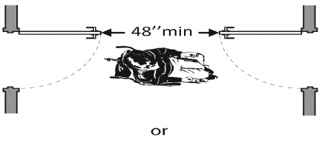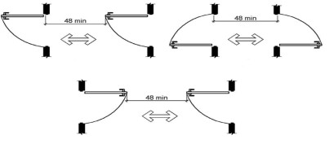

|  |  |  |  |  |
| --- | --- | --- | --- | --- |
| **1.42** Is the door threshold edge no  **TAS** more than ¼” high?  **303.2** *or*  **303.3** No more than ¾” high if slope  **404.2.5** is beveled no steeper than 1:2?  **Note**: First ¼” high of threshold may be vertical; rest must be beveled. | □Yes □No □N/A Measurement:  □Yes □No □N/A Measurement:  |  | Photo #: | • Remove or replace threshold |
| **1.43** Is the door equipped with  **TAS** hardware, including locks, that  **309.4** is operable with one hand and does not require tight grasping, pinching, or twisting of wrist? | □Yes □No □N/A    |  | Photo #: | • Replace inaccessible knob with lever, loop or push hardware  • Add automatic door opener |
| **1.44** Are the operable parts of the  **TAS** door hardware no less than 34”  **404.2.7** and no greater than 48” above the floor or ground surface? | □Yes □No □N/A Measurement:  |  | Photo #: | • Change hardware height |
| **1.45** If the door has a closer, does it  **TAS** take at least 5 seconds to close  **404.2.8.1** from an open position of 90  degrees to a position of 12 degrees from the latch? | □Yes □No □N/A Measurement:  |  | Photo #: | • Adjust closer |
| **1.46** If there are two doors in a  **TAS** series, e.g. vestibule, is the  **404.2.6** distance between the doors at least 48” plus the width of the doors swinging into the space? Note: Requirement applies in all cases - same direction, in‐ swinging, out‐swinging | □Yes □No □N/A Measurement:  |  | Photo #: | • Remove inner door  • Change door swing |

|  |  |  |  |  |
| --- | --- | --- | --- | --- |
| **1.47** If provided at the building  **TAS** entrance, are carpets or mats  **302.2** no higher ½” thick? | □Yes □No □N/A Measurement:  |  | Photo #: | • Replace or remove mats  • Add adhesive or tape to carpet edges |
| **1.48** Are edges of carpets or mats at  **TAS** building entrances securely  **302.2** attached to minimize tripping hazards? | □Yes □No □N/A    |  | Photo #: | • Add adhesive or tape to carpet edges |

**ADA Checklist for 2012 Texas Accessibility Standards (TAS)**

**Priority 2 – Access to Goods and Services**

**Name of Board: Site/Center Name: Physical Address: Date:**

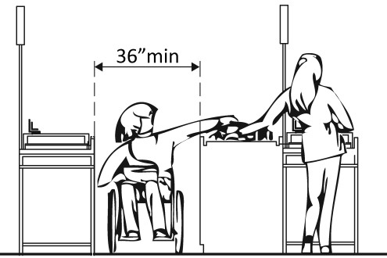

**Reviewer:**

**Contact Information:**

**The layout of the building should allow people with disabilities to obtain goods and services and to participate**

**in activities without assistance.**

|  |  |  |  |  |
| --- | --- | --- | --- | --- |
| **Priority 2 – Access to Goods and Services (Facility Internal Accessible**  **Comments Possible Solutions**  **Elements)** | | | | |
| **2.1** Does the accessible entrance  **TAS** provide direct access to the  **206.2.2** main floor, lobby and elevator?  **Chap 4** | □Yes □No □N/A |  | Photo #: | • Create accessible route |
| **Interior Accessible Route** *(2012 TAS Standards –Chapters 2 (206), 3 (302 and 307), and 4 (402, 403, 404 and 407))* | | | | |
| **2.2** Is there at least one accessible  **TAS** route that connects all  **206.2.2** accessible elements and spaces  **206.4** on the same site and does not require the use of stairs? | □Yes □No □N/A |  | Photo #: | • Create accessible route |
| **2.3** Are floor surfaces of the  **TAS** accessible route stable, firm  **302.1** and slip resistant? | □Yes □No □N/A    |  | Photo #: | • Change floor surface  • Repair uneven or rough  surfaces |
| **2.4** If floor surfaces are carpet or  **TA** carpet tiles, do they have a firm  **302.2** cushion, pad or backing (or no cushion or pad) and pile height is no higher than ½” thick? | □Yes □No □N/A Measurement:  |  | Photo #: | • Replace or remove mats  • Add adhesive or tape to carpet edges |
| **2.5** Are edges of carpets or carpet  **TAS** tile securely attached to  **302.2** minimize wheelchair roll resistance or tripping hazards? | □Yes □No □N/A    |  | Photo #: | Add to carpet edges:  • Adhesive or tape  • Metal or rubber edging  • Transition or threshold finishes |

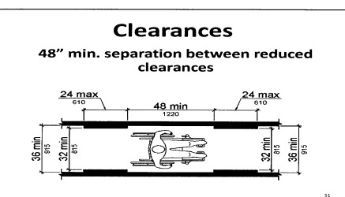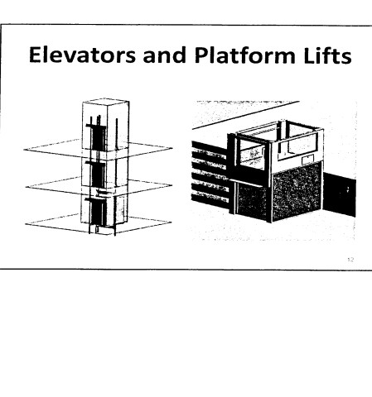

|  |  |  |  |  |
| --- | --- | --- | --- | --- |
| **2.6** Is the route at least 36” wide?  **TAS *Note:*** The accessible route can narrow  **403.5.1** to 32” min. for a max. 24”. These  narrower portions of the route must  be at least 48” from each other. | □Yes □No □N/A Measurement: |  | Photo #: | • Widen route |
| **2.7** For interior ramps, is the  **TAS** running slope no steeper than  **403.3** 1:20 (5%), i.e. for every 1” of height change there are at least 20” of ramp run? | □Yes □No □N/A Measurement:  |  | Photo #: | • Regrade  • If steeper than 1:20 and no steeper than 1:12, treat as ramp and add other features such as edge protection and handrails |
| **2.8** Is the cross slope of the ramp  **TAS** no steeper than 1:48 (2%)?  **403.3** | □Yes □No □N/A Measurement:  |  | Photo #: | • Regrade |
| **2.9** Are there elevators or platform  **TAS** lifts to all public stories?*  **206.2.3 *Note***: Vertical access is not required in  **407** new construction or alterations if a  facility is less than 3 stories or has less  than 3,000 sq. ft. per story, unless a facility is a shopping center, shopping mall, health care provider office, transport terminal, state or gov’t facility. | □Yes □No □N/A |  | Photo #: | • Install if necessary  • Offer goods and services on an accessible story |

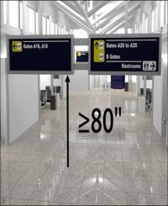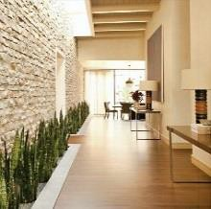

|  |  |  |  |  |
| --- | --- | --- | --- | --- |
| **Protruding Objects** *(2012 TAS Standards – Chapters 2 (204), 3 (307 and 4 (403))* | | | | |
| **2.10** Do all objects on circulation  **TAS** paths through public areas, e.g.  **204.1** fire extinguishers, drinking  **307.2** fountains, signs, etc., protrude no more than 4” into the path? *or*  Is the bottom leading edge at  80” or higher above the floor?  *or*  If an object protrudes more than 4”, is the bottom leading edge at 27” or lower above the floor? |    □Yes □No □N/A Measurement:  □Yes □No □N/A Measurement:  □Yes □No □N/A Measurement: |  | Photo #: | • Remove object  • Add tactile warning such as permanent planter or partial walls |
| **2.11** Are all clear width requirements  **TAS** for accessible routes met for  **204.1** walking surface (min. 36” wide)  **307.4** and vertical clearance (min. 80”  **307.5** high), i.e., protruding objects do  **403.5.1** not reduce the clear width?* | □Yes □No □N/A    |  | Photo #: | • Remove protruding object  *Door closers and door stops shall be permitted to be 78” above the finish floor or ground |
| **Ramps** *(2012 TAS Standards – Chapters 4 (405) and 5 (504 and 505))* **Note: Any portion of an accessible route steeper than 1:20 should be treated as a ramp.** | | | | |
| **2.12** • If there is a ramp (other than  **TAS** curb ramps), is it 36” wide?  **405.5 *Note***: If there are handrails, measure  between the handrails.  • Is the surface stable, firm and slip resistant? | □Yes □No □N/A Measurement:  □Yes □No □N/A |  | Photo #: | • Alter ramp  • Change surface |
| **2.13** For each section of the ramp, is  **TAS** the running slope no greater  **405.2** than 1:12 (8.33%)*? i.e.?  ***Note***: 1:12 slope = For every 1” of height change there are at least 12 inches of ramp run | □Yes □No □N/A Measurement: |  | Photo #: | • Lengthen ramp to decrease slope  • Include ramp switchbacks  • Alter or relocate ramp  **Note**: If space is limited, rises up to 3” with a slope no steeper than 1:8 and rises up to 6” with a slope no steeper than 1:10 are permitted |

|  |  |  |  |  |
| --- | --- | --- | --- | --- |
| **2.14** • Is there a level landing that is  **TAS** at 60” long and at least as  **405.7** wide as the ramp:  **405.7.2** • At the top of the ramp?  **405.7.3**  • At the bottom of the ramp? | □Yes □No □N/A  Measurement:  □Yes □No □N/A  □Yes □No □N/A |  | Photo #: | • Alter ramp  • Relocate ramp |
| **2.15** Where the ramp changes  **TAS** direction, is there a level  **405.7.4** landing that is at least 60” x  60”? | □Yes □No □N/A  Measurement:    |  | Photo #: | • Alter ramp  • Increase landing size |
| **2.16** If the ramp has a rise higher  **TAS** than 6” are there handrails on  **505.2** both sides? | □Yes □No □N/A  Measurement:    |  | Photo #: | • Add handrails |
| **2.17** Is the top of the handrail  **TAS** gripping surface no less than  **505.4** 34” and no greater than 38”  above the ramp surface? | □Yes □No □N/A  Measurement:    |  | Photo #: | • Adjust handrail height |
| **2.18** • Is the handrail gripping  **TA** surface continuous and not  **504.6** obstructed along the top or  sides?  • Is the handrail bottom gripping surface obstructed for no more than 20% of its length? | □Yes □No □N/A  □Yes □No □N/A  Measurement: |  | Photo #: | • Regrade to 1:20 max  • If steeper than 1:20 and no steeper than 1:12, treat as a ramp and add other features such as edge protection and handrails |

|  |  |  |  |  |
| --- | --- | --- | --- | --- |
| **2.19** If the handrail gripping surface  **TAS** is circular, is the diameter  **505.7.1** between 1 ¼” and 2”? | □Yes □No □N/A  Measurement:  |  | Photo #: | • Reconfigure or replace  handrails |
| **2.20** If the handrail gripping surface  **TAS** is non-circular, is the  **505.7.2** perimeter* between 4”-6 ½” and no more than 2 ¼” in cross-section? | □Yes □No □N/A  Measurement:  |  | Photo #: | • Replace handrails  *Perimeter = Distance measured around gripping surface |
| **2.21** Does the handrail:  **TAS** • Extend 12” horizontally  **505.10.1** beyond ramp top and  bottom?  • Return to a wall, guard, or the landing surface? | □Yes □No □N/A  Measurement:  □Yes □No □N/A |  | Photo #: | • Add extensions  • Reconfigure handrails  If a 12” extension would be hazardous (in circulation path), it is not required |
| **2.22** To prevent wheelchair casters  **TAS** and crutch tips from falling off:  **405.9.1** • Does the ramp surface  **405.9.2** extend a min. 12” beyond the  inside face of the handrail?  *or*  • Does a curb/barrier prevent passage of a 4” diam. sphere? |    □Yes □No □N/A  Measurement:  □Yes □No □N/A  Measurement: |  | Photo #: | • Add curb  • Add barrier  • Extend ramp width |
| **Elevators** *(2012 TAS Standards – Chapters 3 (308), 4 (407) and 7 (703))* | | | | |
| If either a full- size or LULA (Limited Use, Limited Application) elevator is provided at the facility location : | | | | |
| **2.23** Are call control buttons no  **TAS** higher than 54” above the  **308** floor?  **407.2.1.1** | □Yes □No □N/A  Measurement: |  | Photo #: | • Change call button height |

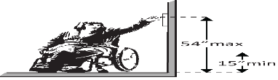

|  |  |  |  |  |  |
| --- | --- | --- | --- | --- | --- |
| **2.24**  **TAS**  **407.3.3** | Are elevator doors provided with a reopening device that will stop and reopen a door automatically obstructed by an object or person?* | □Yes □No □N/A |  | Photo #: | * If constructed before  3/15/2012 and manually operated, not required to reopen automatically  • Install opener |
| **2.25**  **TAS**  **407.4.1** | For a full size elevator:  • Is the interior at least 54” deep by 36” wide with 16 sq. ft. of clear floor area?  • Is door opening width 32”? | □Yes □No □N/A  Measurement:   □Yes □No □N/A  Measurement: |  | Photo #: | • Replace elevator |
| **2.26**  **TAS**  **308**  **407.6.1** | Are the in-car controls:  • No less than 15” and no greater 48” above the floor?  *or*  • Up to 54” above the floor for a parallel approach? | □Yes □No □N/A  Measurement:   □Yes □No □N/A  Measurement:  | *or* | Photo #: | • Change control height |
| **2.27**  **TAS**  **407.4.6.2** | • Do car control buttons have raised or flush characters*?  • Do car control buttons have Braille designations immediately to the left of the controls to which the designation applies^? | □Yes □No □N/A  □Yes □No □N/A |  | Photo #: | • Add raised characters  • Add Braille  *In existing elevators, buttons may be recessed  ^Where existing car panels  preclude tactile markings to left of controls, may place near to controls as possible |
| **2.28**  **TAS**  **407.4.6.2** | Is the call button that designates the up direction located above the call button that designates the down direction? | □Yes □No □N/A |  | Photo #: | • Reconfigure buttons |

|  |  |  |  |  |
| --- | --- | --- | --- | --- |
| **2.29** Do hall signals have a visual  **TAS** signal at each elevator  **407.2.2.2** entrance to indicate which car  is answering a call and the car’s  direction of travel? | □Yes □No □N/A |  | Photo #: | • Install audible signals |
| **2.30** Are there audible signals which  **TAS** sound once for the up  **407.2.2.3** direction and twice for the  down direction or have verbal annunciators that indicate the direction of elevator car travel? | □Yes □No □N/A |  | Photo #: | • Install audible signals |
| **2.31** Do both elevator door jambs at  **TAS** every floor have signs:  **407.2.3.1** • Identifying the floor number?  **407.2.3.2**  **703.2** •Does main entry level have a  **703.4.1** tactile star on both jambs?  •Characters tactile and Braille?  •Mounted between 48” of  lowest character and 60” of highest character above floor?* | □Yes □No □N/A  □Yes □No □N/A  □Yes □No □N/A  □Yes □No □N/A  Measurement: |  | Photo #: | • Install signs  • Change sign height  * If constructed before  3/15/12 and the sign is mounted no higher than  60” to centerline of the sign, relocation is not required |
| **Signs at Permanent Rooms and Spaces** *(2012 TAS Standards – Chapters 2 (216) and 7 (703))* **Note: “Tactile characters” are read using touch, i.e. raised characters and**  **Braille** | | | | |
| **2.32** For signs at permanent rooms  **TAS** and spaces, i.e., those not  **216.2** likely to change over time:  **703.1** • Is the sign mounted on wall  **703.2** adjacent to latch side of  **703.3** door?  **703.4**  **703.5** • Where there is no wall space  at the latch side of a single  door, is the sign mounted on  the nearest adjacent wall? |       □Yes □No □N/A  □Yes □No □N/A |  |  | • Install tactile sign  • Relocate sign  Note:  Signs are permitted on the  push side of doors with closers and without hold- open devices. |

|  |  |  |  |  |
| --- | --- | --- | --- | --- |
| • Where at double doors, is the sign mounted on the  right side if there are 2 active leafs or only 1 active leaf?  • Are text characters raised and duplicated in Braille?  • Is the sign located 48” min. above the floor measured from the baseline of the lowest tactile character and  60” maximum above the  highest character above the floor?*  • Is there a clear floor space at least 18” x 18” beyond the arc of the door swing between the closed position and 45-degree open position for signs centered on their tactile characters?^ |    □Yes □No □N/A     □Yes □No □N/A  □Yes □No □N/A           □Yes □No □N/A |  | Photo #: | *If constructed before  3/15/2012 and mounted no higher than 60” to the centerline of the sign, relocation is not required  ^If constructed before  3/15/2012 and a person can approach within 3 inches of the sign without encountering protruding objects or standing within the door swing, relocation is not required |
| **2.33** If there are signs that provide  **TAS** direction to or information  **216.3** about interior spaces:  **703.5** • Do text characters contrast  with their backgrounds?  • Is the sign mounted so visual characters are at least 40” above floor finish? |       □Yes □No □N/A  □Yes □No □N/A  Measurement:  |  | Photo #: | • Install signs with contrasting characters  • Change sign height  Raised characters and Braille are not required for signs that provide direction or information |

|  |  |  |  |  |
| --- | --- | --- | --- | --- |
| **Interior Doors at Rooms and Spaces** *(2012 TAS Standards –Chapter 4 (404))* | | | | |
| **2.34** Is the door opening width at  **TAS** least 32” clear between the  **404.2.3** face of the door and the stop when the door is open 90 degrees? | □Yes □No □N/A  Measurement:  |  | Photo #: | • Install offset hinges  • Alter the doorway |
| **2.35** • If there is a front approach to  **TAS** pull side of the door, is there  **404.2.4.1** at least 18” of maneuvering  **404.2.4.4** clearance beyond the latch  side plus 60” clear depth?  • As no change in level allowed, is the ground or floor surface of maneuvering clearance no steeper than 1:48 (2% slope)? | □Yes □No □N/A Measurement:  □Yes □No □N/A Measurement: |  | Photo #: | • Remove obstructions  • Reconfigure walls  • Add automatic door opener  See 2010 Standards 404.2.4 for maneuvering clearance requirements on the push side of the door and side approaches to the pull side of the door |
| **2.36** Is the door threshold edge no  **TAS** more than ¼” high?  **303.2** *or*  **303.3** No more than ¾” high if slope  **404.2.5** is beveled no steeper than 1:2?  ***Note***: First ¼” high of threshold may be  vertical; rest must be beveled. | □Yes □No □N/A Measurement:  □Yes □No □N/A Measurement:  |  | Photo #: | • Remove or replace threshold |
| **2.37** Is the door equipped with  **TAS** hardware, including locks, that  **309.4** is operable with one hand and does not require tight grasping, pinching, or twisting of wrist? | □Yes □No □N/A    |  | Photo #: | • Replace inaccessible knob with lever, loop or push hardware  • Add automatic door opener |

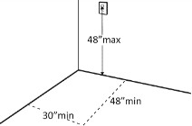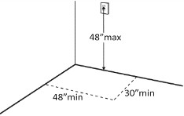

|  |  |  |  |  |  |  |
| --- | --- | --- | --- | --- | --- | --- |
| **2.38** Are the operable parts of the  **TAS** door hardware no less than  **404.2.7** 34” and no greater than 48” above the floor or ground surface? | □Yes □No □N/A Measurement:  |  | Photo #: | | • Change hardware height | |
| **2.39** If the door is an interior hinged  **TAS** door, can it be opened with no  **404.2.9** more than 5 pounds of force maximum?  ***Note***: There is no pounds of force requirement for exterior doors. | □Yes □No □N/A  Measurement:    |  | Photo #: | | • Adjust or replace closers  • Install lighter doors  • Install power-assisted or automatic door openers | |
| **2.40** If the door has a closer, does it  **TAS** take at least 5 seconds to close  **404.2.8.1** from an open position of 90  degrees to a position of 12 degrees from the latch? | □Yes □No □N/A Measurement:  |  | Photo #: | | • Adjust closer | |
| **Controls and Operable Parts** *(2012 TAS Standards – Chapters 2 (205) and 3 (305, 308 and 309))* | | | | | | |
| **2.41** • Is there a clear floor space at  **TAS** least 30” wide x 48” long for  **205** forward or parallel approach  **305.3** at controls?  **308.2.1** • Is the unobstructed high  **309** forward reach for operable parts no higher than 48” above floor?*  • Is the unobstructed low forward reach for operable parts no lower than 15” above floor? | □Yes □No □N/A Measurement:  □Yes □No □N/A Measurement:  □Yes □No □N/A Measurement: |  | | Photo #: | | • Change height of control  *If constructed before  3/15/2012 and a parallel  approach is provided, controls can be 54” above the floor |
| **2.42** Can the control be operated  **TAS** with one hand and without  **205** tight grasping, pinching, or  **309.4** twisting of the wrist? | □Yes □No □N/A    |  | | Photo #: | | • Replace control |

|  |  |  |  |  |
| --- | --- | --- | --- | --- |
| **Seating and Work Surfaces** *(2012 TAS Standards – Chapters 1 , (106), 2 (206 and 221), 3 (305 and 306), 4 (403), 8 (802), and 9 (902))* | | | | |
| **2.43** Are wheelchair spaces  **TAS** integrated into the seating plan  **106.5.10** of classrooms, public  **221.2.2** meeting/hearing rooms, etc.*?  *Assembly area: A building or facility, or portion thereof, used for…civic or educational gatherings or similar purposes. They include, but are not limited to, classrooms, public meeting or hearing rooms, lecture halls, etc. | □Yes □No □N/A          |  | Photo #: | • Provide wheelchair spaces throughout assembly area |
| **2.44** Do wheelchair spaces in rooms  **TAS** meet minimum numbers, but  **221.2.1.1** not less than one, based on  total number of seating? | □Yes □No □N/A  Total #: Wheelchair #: |  | Photo #: | • Adjust seating to provide accessible spaces |
| **2.45** Are wheelchair spaces at least  **TAS** 36” wide or 33” wide where  **802.1.2** two adjacent wheelchair spaces are provided? | □Yes □No □N/A  Measurement: |  | Photo #: | • Adjust size of space |
| **2.46** Do wheelchair spaces provide  **TAS** lines of sight and viewing angles  **221.2.3** that are dispersed and  **802.2** substantially equivalent to that of other members of the audience (neither the best nor the worst seats in the house)? | □Yes □No □N/A    |  | Photo #: | • Re-disperse wheelchair spaces |
| **2.47** Is there a route at least 36”  **TAS** wide to accessible seating?  **206.2.2**  **403.5.1** | □Yes □No □N/A  Measurement:  |  | Photo #: | • Widen route |

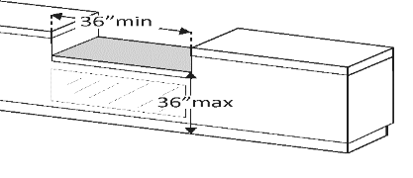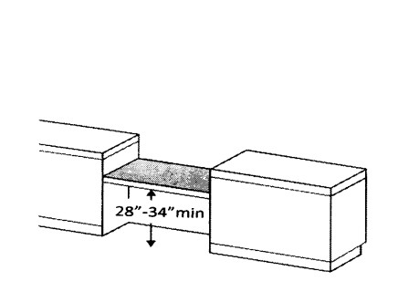

|  |  |  |  |  |  |  |
| --- | --- | --- | --- | --- | --- | --- |
| **2.48** Is there at least one space 36”  **TAS** wide by 48” deep if entered  **802.1.3** from the front for a person in a wheelchair? | □Yes □No □N/A  Measurement:  |  | Photo #: | | • Move furniture and equipment to provide space | |
| **2.49** Is the top of the accessible  **TAS** work surface between 28” and  **902.3** 34” above the floor? | □Yes □No □N/A  Measurement:  |  | Photo #: | | | • Alter surface height |
| **2.50** • Is there a clear floor space at  **TAS** least 30” wide by 48” long  **305** for a forward approach?  **306** • Is there knee and toe  **902.2** clearance at least 27” high  by 30” wide by 17”-25”  deep? | □Yes □No □N/A  Measurement:  □Yes □No □N/A  Measurement: |  | Photo #: | | | • Alter table or work surface  • Add accessible table or work surface |
| **Reception and Service Counters** *(2012 TAS Standards – Chapters 2(227), 3 (305), and 9 (902 and 904))* | | | | | | |
| **2.51** For customer reception and  **TAS** service counters, is the  **227.3** accessible portion of the  **902.3** counter top:  **904.4.1** • no higher than 36” above the floor and at least 36” long?  • between 28”-34” maximum above the floor” |       □Yes □No □N/A  Measurement:  □Yes □No □N/A  Measurement: |  | Photo #: | • Lower section of counter  • Lengthen section of counter | | |

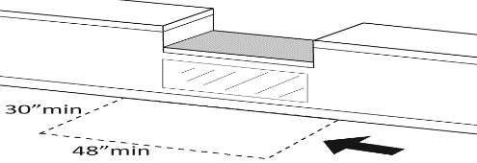

|  |  |  |  |  |
| --- | --- | --- | --- | --- |
| **2.52** Does the accessible portion of  **TAS** the counter extend the same  **904.4** depth as the counter top? | □Yes □No □N/A  Measurement:  |  | Photo #: | • Alter accessible portion |
| **2.53** Is there a clear floor space at  **TAS** least 30” wide by 48” long for a  **305.3** forward or parallel approach?  **305.5**  **904.4.1**  **904.4.2** | □Yes □No □N/A  □Parallel Measurement:  □Forward  Measurement: | ***or*** | Photo #: | • Reconfigure to provide a parallel or forward approach |
| **2.54** For a parallel approach:  **TAS** Is the clear floor space  **305.3** positioned with the 48 inches  **904.4.1** adjacent to the accessible  length of counter? | □Yes □No □N/A  Measurement:    |  | Photo #: | • If a parallel approach is not possible, a forward approach is required |
| **2.55** For a forward approach:  **TAS** • Does no less than 17” and no  **305.4** more than 25” of the clear  **305.6** floor space extend under the  **904.4.2** accessible length of the  counter?  • Is there at least 27” clearance from floor to counter  bottom? |    □Yes □No □N/A  Measurement:  □Yes □No □N/A  Measurement: |  | Photo #: | • Reconfigure to provide knee clearance |

**ADA Checklist for 2012 Texas Accessibility Standards (TAS)**

**Priority 3 - Toilet Facilities**

**Name of Board: Site/Center Name: Physical Address: Date:**

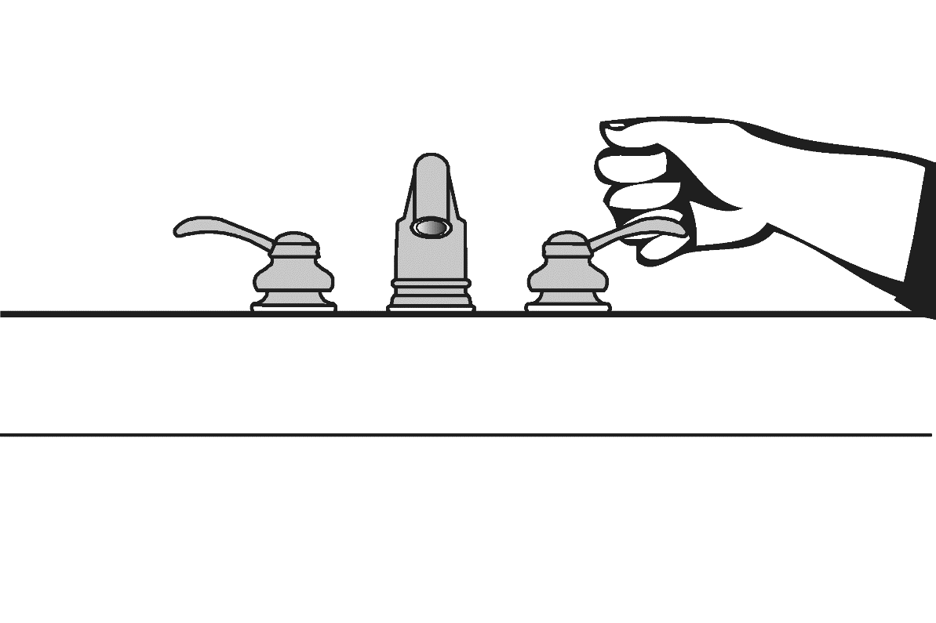

**Reviewer:**

**Contact Information:**

**When toilet rooms are open to the public they should be accessible to people with disabilities.**

|  |  |  |  |  |
| --- | --- | --- | --- | --- |
| **Priority 3 – Toilet Facilities Comments Possible Solutions** | | | | |
| **3.1** If toilet facilities are provided  **TAS** to the public, is at least one  **213.2** toilet room accessible (either one for each sex or one unisex)?  ***Note:*** Exceptions are provided for no fewer than one accessible toilet room due to technical infeasibility in ability to comply with 603 or for qualified historic buildings or facilities | □Yes □No □N/A |  | Photo #: | • Reconfigure toilet rooms  • Combine toilet rooms to  create one unisex accessible toilet room |
| **3.2** Do inaccessible toilet rooms  **TAS** have directional signs indicating  **216.8** the location of accessible toilet rooms? | □Yes □No □N/A |  | Photo #: | • Install signs |
| **3.3** If not all toilet rooms are  **TAS** accessible, is the accessible  **216.8** toilet room identified by the International Symbol of Accessibility? | □Yes □No □N/A |  | Photo #: | • Install sign |
| **Accessible Route** *(2012 TAS Standards – Chapter 2 (206))* | | | | |
| **3.4** Is the accessible toilet room(s):  **TAS** • On an accessible route?  **206.2.2** • Does the accessible route  **206.2.4** avoid the use of stairs? | □Yes □No □N/A  □Yes □No □N/A |  | Photo #: | • Alter route |

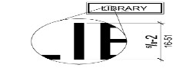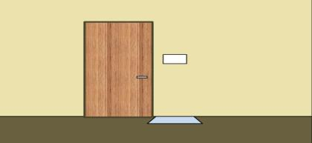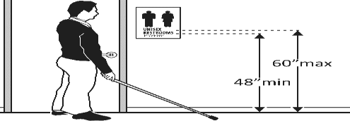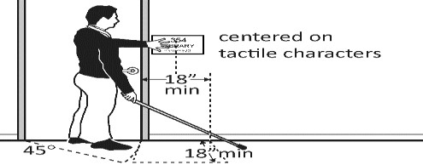

|  |  |  |  |  |
| --- | --- | --- | --- | --- |
| **Signs at Toilet Rooms** *(2012 TAS Standards – Chapters 2 (216) and 7 (703))* | | | | |
| **3.5** Signs shall comply with 703:  **TAS** • Do text characters contrast  **216.3** with their backgrounds?  **216.8** • Are text characters raised and  **703.2** duplicated in Braille?  **703.7.2.1** | □Yes □No □N/A  □Yes □No □N/A |  | Photo #: | • Install tactile, Braille  and/or combined character sign  ***Note***: Where visual and tactile characters are required, either one sign with both visual and tactile characters, or two separate signs (one with visual and one with tactile characters) shall be provided. |
| **3.6** Is the sign mounted:  **TAS** • On the wall adjacent to the  **216.8** latch side of the door?  **703.4.1** • Is the baseline of the lowest  **703.4.2** character at least 48” above  the floor and the baseline of the highest character no more than 60” above the floor?*  • Is there clear floor space at least 18” x 18” beyond the arc of the door swing between the closed position and 45-degree open position for signs centered on their tactile characters?^  **Note:** Signs are permitted on the push side of doors with closers and without hold- open devices. | □Yes □No □N/A  □Yes □No □N/A  □Yes □No □N/A |  |  | *If constructed before  3/15/2012 and mounted no higher than 1524 mm (60 inches) to the centerline of the sign, relocation is not required  ^If constructed before  3/15/2010 and a person may approach within 76.2 mm (3 inches) of the sign without encountering protruding objects or standing within the door swing, relocation not required |
| **Entrance and Doors** *(2012 TAS Standards – Chapters 2 (206), 3 (303 and 309) and 4 (404))* | | | | |
| **3.7** Is the door opening width at  **TAS** least 32” clear between the  **206.5.2** face of the door and the stop  **404.2.3** when the door is open 90  degrees? | □Yes □No □N/A  Measurement: |  | Photo #: | • Install offset hinges  • Alter the doorway |

|  |  |  |  |  |
| --- | --- | --- | --- | --- |
| **3.8** • If there is a front approach to  **TAS** pull side of the door, is there  **404.2.4** at least 18” of maneuvering  **404.2.4.4** clearance beyond the latch  side plus 60” clear depth?  • As no change in level is allowed, is the floor surface of the maneuvering clearance on both sides of the door no steeper than 1:48 (2% slope)? | □Yes □No □N/A  Measurement:  □Yes □No □N/A  Measurement: |  | Photo #: | • Remove obstructions  • Reconfigure walls  • Add automatic door opener  ***Note:*** See 2012 TAS Standards  404.2.4 for maneuvering  clearance requirements on the push side of the door and side approaches to the pull side of the door |
| **3.9** Is the door threshold edge no  **TAS** more than ¼” high?  **303.2** *or*  **303** No more than ¾” high if slope is  **404.2.5** beveled no steeper than 1:2?  ***Note***: First ¼” of threshold may be  vertical; rest must be beveled. | □Yes □No □N/A  Measurement:  □Yes □No □N/A  Measurement:  |  | Photo #: | • Remove or replace threshold |
| **3.10** Is the door equipped with  **TAS** hardware, including locks, that  **309.4** is operable with one hand and does not require tight grasping, pinching, or twisting of wrist? | □Yes □No □N/A |  | Photo #: | • Replace knobs or latches with lever or loop handles  • Install power-assisted or automatic door openers |
| **3.11** Are the operable parts of the  **TAS** door hardware mounted no less  **404.2.7** than 34” and no greater than  48” above the floor? | □Yes □No □N/A  Measurement: |  | Photo #: | • Change hardware height |
| **3.12** Can the door be opened with 5  **TAS** pounds of force or less?  **404.2.9** | □Yes □No □N/A  Measurement: |  | Photo #: | • Adjust or replace closers  • Install lighter doors  • Install power-assisted or automatic door openers |

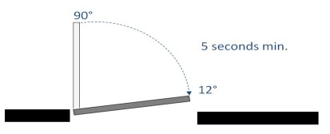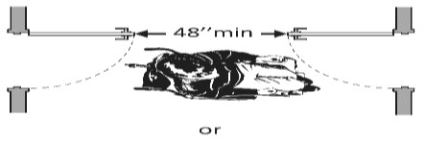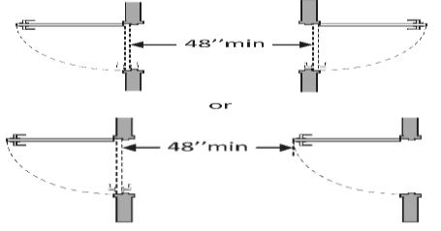

|  |  |  |  |  |
| --- | --- | --- | --- | --- |
| **3.13** If the door has a closer, does it  **TAS** take at least 5 seconds to close  **404.2.8.1** from an open position of 90 degrees to a position of 12 degrees from the latch? | □Yes □No □N/A  Measurement:    |  | Photo #: | • Adjust closer |
| **3.14** If there are two doors in a  **TAS** series (e.g. vestibule) is the  **404.2.6** distance between the doors at least 48” plus the width of the doors when swinging into the space? | □Yes □No □N/A  Measurement: |  | Photo #: | • Remove inner door  • Change door swing |
| **3.15** If there is a privacy wall and the  **TAS** door swings out, is there:  **404.2.4.1** • at least 24” of maneuvering clearance beyond the door latch side  • 42” between the door and  privacy wall, and  • 48” between the privacy wall and the wall perpendicular to the privacy wall? |    □Yes □No □N/A  Measurement:  □Yes □No □N/A  Measurement:  □Yes □No □N/A  Measurement: |  | Photo #: | • Reconfigure space |
| **3.16** If there is a privacy wall and the  **TAS** door swings in, is there:  **404.2.4.1** • at least 24” of maneuvering clearance beyond the door latch side  • at least 48” to the privacy wall if there is no door closer or at 54” if there is a door closer? |    □Yes □No □N/A  Measurement:  □Yes □No □N/A  Measurement: |  | Photo #: | • Reconfigure space |

|  |  |  |  |  |
| --- | --- | --- | --- | --- |
| **General Toilet Room Requirements** *(2012 TAS Standards – Chapters2 (206), 3 (304, 305 and 308), 4 (403) and 6 (603 and 604))* | | | | |
| **3.17** Is there a clear path to at least  **TAS** one of each type of fixture (e.g.  **206.2.2** lavatory, hand dryer, etc.) that  **206.2.4** is at least 36” wide?  **403.5.1 *Advisory 206.2.4 Spaces and Elements***: Accessible routes must connect all spaces and  elements required to be accessible. | □Yes □No □N/A  Measurement:    |  | Photo #: | • Remove obstructions |
| **3.18** Is there clear floor space  **TAS** available for a person in a  **304.3.1** wheelchair to turn around, i.e. a  **304.3.2** circle at least 60” in diameter or  **304.4** a T-shaped space within a 60”  **603.2.1** square?  ***Note:*** The door to the toilet room may swing into the required turning space |    □Yes □No □N/A  Measurement: |  | Photo #: | • Move or remove partitions, fixtures or objects such as trash cans |
| **3.19** In a single user toilet room  **TAS** where the door swings into the  **305.3** clear floor space, is there at  **603.2.3** least 30” x 48” of clear floor  **Exception 2** space at the accessible fixture  beyond the swing of the door? | □Yes □No □N/A  Measurement: |  | Photo #: | • Reverse door swing  • Alter toilet room |
| **3.20** If a coat hook is provided, is it  **TAS** between 15” and 48” above the  **308.3.1** floor?  **603.4**  **604.8.3** | □Yes □No □N/A  Measurement: |  | Photo #: | • Adjust hook  • Replace with or provide  additional accessible hook |
| **Lavatories and Mirrors** *(2012 TAS Standards – Chapters 2 (205 and 213), 3 (305, 306 and 309) and 6 (605 and 606))* **Note: TAS Standards refer to sinks in toilet rooms as lavatories.** | | | | |
| **3.21** Does at least one lavatory have  **TAS** a clear floor space for a forward  **213.3.4** approach measuring at least  **305.3** 30” x 48”?  **605.3** | □Yes □No □N/A  Measurement: |  | Photo #: | • Alter lavatory  • Replace lavatory |

|  |  |  |  |  |
| --- | --- | --- | --- | --- |
| **3.22** In order to reach the faucet, is  **TAS** toe clearance at lavatories:  **213.3.4** • 17” min to 25” max deep  **606.2** under a lavatory?  **306.2**  • 30” min wide?  • 9” high from floor finish? ***Note***: Space extending greater than 6” beyond the available knee clearance at 9” above the floor is not considered toe clearance | □Yes □No □N/A  Measurement:  □Yes □No □N/A  Measurement:  □Yes □No □N/A  Measurement: |  | Photo #: | • Alter lavatory  • Replace lavatory |
| **3.23** In order to reach the faucet, is  **TAS** knee clearance at lavatories:  **213.3.4** • 11” min to 25” max deep  **606.2** under a lavatory, and  **306.3** • 30” min wide  • 27” from the floor to the bottom of the lavatory and 8” deep under the lavatory? | □Yes □No □N/A  Measurement:  □Yes □No □N/A  Measurement: |  | Photo #: | • Alter lavatory  • Replace lavatory |
| **3.24** Is the front of the lavatory rim  **TAS** or counter surface, whichever is  **213.3.4** higher, no more than 34” above  **606.3** the finish floor? | □Yes □No □N/A  Measurement: |  | Photo #: | • Alter lavatory  • Replace lavatory |
| **3.25** Below the lavatory/sink:  **TAS** • Are pipes insulated or  **213.3.4** otherwise configured to  **606.5** protect against contact?  • There are no sharp or abrasive surfaces underneath? | □Yes □No □N/A  □Yes □No □N/A |  | Photo #: | • Install insulation  • Install cover panel |
| **3.26** Can the faucet:  **TAS** • be operated with 1 hand w/o  **205** tight grasping, pinching, or  **309.4** twisting of the wrist?  **606.4** • be activated with no more than 5 pounds of force? | □Yes □No □N/A  □Yes □No □N/A |  | Photo #: | • Adjust faucet  • Replace faucet |

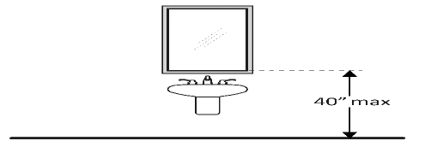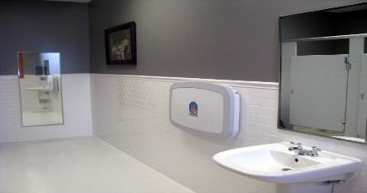

|  |  |  |  |  |  |
| --- | --- | --- | --- | --- | --- |
| **3.27** If a mirror is located:  **TAS** • above a lavatory or counter-  **213.3.5** top, is the bottom edge of the  **603.3** reflecting surface 40”  maximum above the floor?  • not above a lavatory or countertop, is the bottom edge of the reflecting surface  35” max. above the floor?* ***Advisory***: If a single full-length mirror is provided, the top edge of the mirror should be 74” minimum from the floor or ground. | | □Yes □No □N/A  Measurement:  □Yes □No □N/A  Measurement:  |  | Photo #: | • Lower the mirror  • Add another mirror  * If installed before 3/15/12 and the bottom edge of the reflecting surface is no higher than 40” above the floor, lowering the mirror to 35” is not required |
| **Soap Dispensers and Hand Dryers** *(2012 TAS Standards –Chapters 2 (205) and 6 (603))* | | | | | |
| **3.28** Soap Dispensers  **TAS** Is the forward reach for the  **205** operable parts of the soap  **308.2.1** dispenser located above  **309** lavatories or counters:  • no higher than 44” above the  floor for lavatories/counters  20”-25” deep?  • no higher than 48” above the  floor for lavatories/counters  20” or less deep?  Is the forward reach for the operable parts of the soap dispenser not located above lavatories or counters:  • no higher than 48” above the  floor |    □Yes □No □N/A  Measurement:  □Yes □No □N/A  Measurement:        □Yes □No □N/A  Measurement: | |  | Photo #: | • Adjust dispensers  • Replace with or provide additional accessible dispensers |

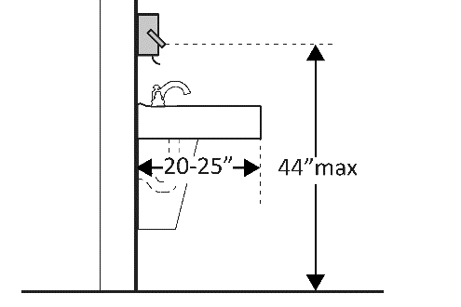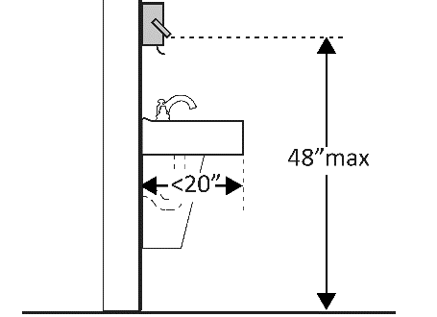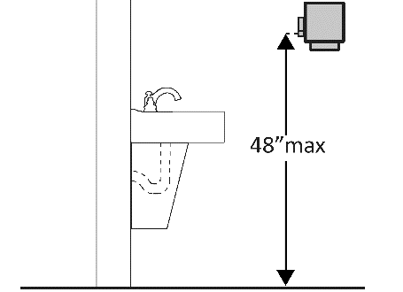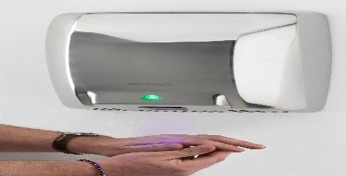

|  |  |  |  |  |
| --- | --- | --- | --- | --- |
| **3.29** Hand Dryer or Towel Dispenser  **TAS** Is the forward reach for the  **205** operable parts of the hand  **308.2.1** dryer or towel dispenser  **309** located above lavatories or  counters:  • no higher than 44” above the  floor for lavatories/counters  20”-25” deep?  • no higher than 48” above the  floor for lavatories/counters  20” or less deep?  Is the forward reach for the operable parts of the hand dryer or towel dispenser not located above lavatories or counters:  • no higher than 48” above the  floor  Can the operable parts of the hand dryer or towel dispenser be operated without tight grasping, pinching or twisting of the wrist?  Is the force required to activate the hand dryer or towel dispenser no greater than 5 pounds? |                □Yes □No □N/A  Measurement:  □Yes □No □N/A  Measurement:  □Yes □No □N/A  Measurement:  □Yes □No □N/A  Measurement:  □Yes □No □N/A  □Yes □No □N/A |  | Photo #: | • Adjust dispensers  • Replace with or provide additional accessible dispensers |

|  |  |  |  |  |
| --- | --- | --- | --- | --- |
| **Water Closets, Grab Bars and Dispensers in Toilet Rooms** *(2012 TAS Standards – Chap 2 (213), 3 (308 and 309) and 6 (604 and 609))* **Note: Toilets are called water closets.** | | | | |
| **3.30** Is the centerline of the water  **TAS** closet between 16”-18” from  **213** the side wall or partition?  **604.2** | □Yes □No □N/A  Measurement: |  | Photo #: | • Move toilet  • Replace toilet  • Move partition |
| **3.31** Is clearance around the water  **TAS** closet at least 60” from the  **213** side wall and at least 56” from  **604.3.1** the rear wall?*  **604.3.2** *If constructed before 3/15/12, clearances around water closets in single user toilet rooms can be 48” x  66” or 48” x 56” (depending on approach to water closet, see 1994  TAS Standards Figure 28). Lavatory may overlap that clearance if the door to the room does not swing into required clearances at fixtures (e.g., lavatories, water closet and urinals) and the edge of lavatory is at least 18” from center-line of the water closet | □Yes □No □N/A  Measurement: |  | Photo #: | • Alter room/compartment for clearance |
| **3.32** Is the height of the water  **TAS** closet between 17”-19” above  **213** the floor measured to the top  **604.4** of the seat? | □Yes □No □N/A  Measurement: |  | Photo #: | • Adjust toilet height  • Replace toilet |

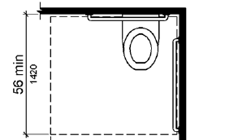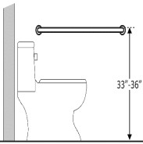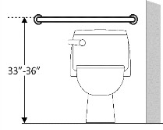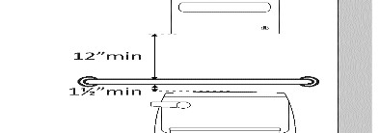

|  |  |  |  |  |
| --- | --- | --- | --- | --- |
| **3.33** Are grab bars provided on the  **TAS** side wall closest to the water  **213** closet and on the rear wall?  **604.5** | □Yes □No □N/A |  | Photo #: | • Install grab bars |
| **3.34** Grab bars at Toilet Rooms:  **TAS** • Are they mounted between  **213** 33”-36” above the floor to  **604.5** top of the gripping surface?  **609.4**  • Have at least 1½” clearance  between the grab bar and  projecting objects below?*  • Have a 1 ½” space between the wall and the grab bar? | □Yes □No □N/A  Measurement:  □Yes □No □N/A  Measurement:  □Yes □No □N/A  Measurement: |  | Photo #: | • Relocate grab bar  * If constructed before  3/15/2012 grab bars do not need to be relocated; there are no space requirements above and below grab bars in the  1994 TAS Standards |
| **3.35** Is the side wall grab bar:  **TAS** • at least 42” long?  **213**  **604.5.1** • located no more than 12”  **609.3** from the rear wall?  • mounted so it extends at least 54” from the rear wall? | □Yes □No □N/A  Measurement:  □Yes □No □N/A  Measurement:  □Yes □No □N/A  Measurement: |  | Photo #: | • Install grab bar  • Relocate grab bar  • Relocate objects |
| **3.36** Is the rear wall grab bar:  **TAS** • at least 36” long?  **213** • mounted so it extends at  **604.5.2** least 12” from the centerline  **609.3** of the water closet on the  side wall?  • mounted so it extends at least 24” on the open side? | □Yes □No □N/A  Measurement:  □Yes □No □N/A  Measurement:  □Yes □No □N/A  Measurement: |  | Photo #: | • Install grab bar  • Relocate grab bar  • Relocate objects |

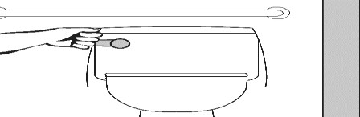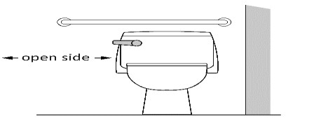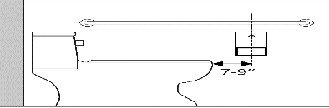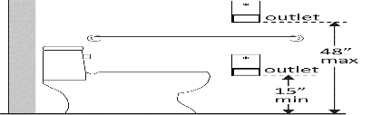

|  |  |  |  |  |
| --- | --- | --- | --- | --- |
| **3.37** If the flush control is hand  **TAS** operated, is the operable part  **213** located no higher than 48”  **308.3.1** above the floor? | □Yes □No □N/A  Measurement: |  | Photo #: | • Move control  • Install sensor with override button no higher than 48 inches |
| **3.36** If the flush control is hand  **TAS** operated:  **213** • Can it be operated with one  **309.4** hand w/o tight grasping,  **604.6** pinching, or twisting of wrist?  • Can it be activated with 5 pounds of force or less?  • Is it located on the open side of the water closet? |    □Yes □No □N/A  □Yes □No □N/A  □Yes □No □N/A |  | Photo #: | • Change control  • Adjust control  • Move control |
| **3.37** For toilet paper dispensers:  **TAS** • Is it located between 7”-9”  **213** from front of water closet to  **604.7** centerline of dispenser?*  **604.9.6** • Is the outlet of the dispenser located between 15”-48” maximum above the floor?  • Is not located behind grab bars?  • Is there continuous paper flow? | □Yes □No □N/A  Measurement:  □Yes □No □N/A  Measurement:  □Yes □No □N/A  □Yes □No □N/A |  | Photo #: | • Relocate dispenser  • Adjust dispenser  • Replace dispenser  * If constructed before 3/15/2012 dispenser does not need to be relocated if it is within reach from the water closet seat; the  1991 Standards do not specify  distance from the front of the water closet |
| **Toilet Compartments (Stalls)** (*2010 Standards – 604)* | | | | |
| **3.38** Is the door opening width at  **TAS** least 32” clear between the face  **213** of the door and the stop when  **404.2.3** the door is open 90 degrees?  **604.8.1.2** | □Yes □No □N/A  Measurement: |  | Photo #: | • Widen door width |

|  |  |  |  |  |
| --- | --- | --- | --- | --- |
| **3.39** If there is a front approach to  **TAS** the pull side of the door, is  **404.2.4.1** there at least 18” maneuvering clearance beyond the latch side plus 60” clear depth?* | □Yes □No □N/A  Measurement: |  | Photo #: | • Remove obstructions  *See 604.8.1.2 Doors for maneuvering clearance requirements on the push side of the door and side approaches to the pull side of the door |
| **3.40** Is the door self-closing?  **TAS**  **604.8.2.2** | □Yes □No □N/A |  | Photo #: | • Add closer  • Replace door |
| **3.41** Is the door have door pulls on  **TAS** both sides of the door near the  **309.4** latch operable with one hand  **404.2.7** and does not require tight  **604.8.2.2** grasping, pinching, or twisting of wrist? | □Yes □No □N/A |  | Photo #: | • Replace hardware  * If constructed before 3/15/2012 door pulls do not need to be added; door pulls are not required in the 1994 Standards |
| **3.42** Is the lock operable with one  **TAS** hand and without tight  **309.4** grasping, pinching or twisting of  **404.2.7** the wrist? | □Yes □No □N/A |  | Photo #: | • Replace lock |
| **3.43** Are the operable parts of the  **TAS** door hardware mounted  **308.3.2** between 34”-48” above the  **309.3** floor? | □Yes □No □N/A  Measurement: |  | Photo #: | • Relocate hardware |
| **3.44** Is the compartment at least 60”  **TAS** wide?  **304.3.1**  **603.2** | □Yes □No □N/A  Measurement: |  | Photo #: | • Widen compartment |
| **3.45** • If the water closet is wall  **TAS** hung, is the compartment at  **604.8.1.1** least 56” deep? | □Yes □No □N/A  Measurement:  □Yes □No □N/A |  |  | • Widen compartment  • Alter compartment |

|  |  |  |  |  |
| --- | --- | --- | --- | --- |
| • If the water closet is floor mounted, is the compartment at least 59” deep? | Measurement: |  | Photo #: |  |
| **3.46** Is the rim of the urinal (stall  **TAS** type or wall-hung) a maximum  **605.2** of 17” above the floor finish? | □Yes □No □N/A  Measurement: |  | Photo #: | • Adjust height |

**ADA Checklist for 2012 Texas Accessibility Standards (TAS)**

**Priority 4 – Additional Access Elements**

**Name of Board: Site/Center Name: Physical Address: Date:**

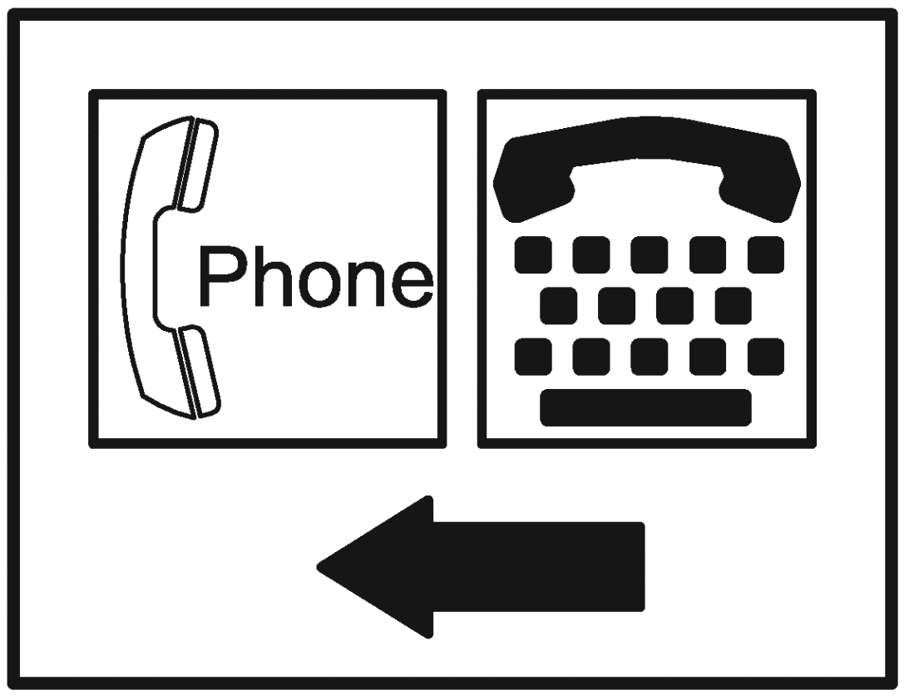

**Reviewer:**

**Contact Information:**

**Amenities such as drinking fountains and public telephones should be accessible to people with disabilities.**

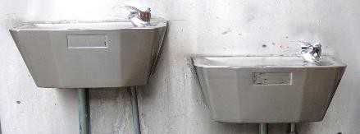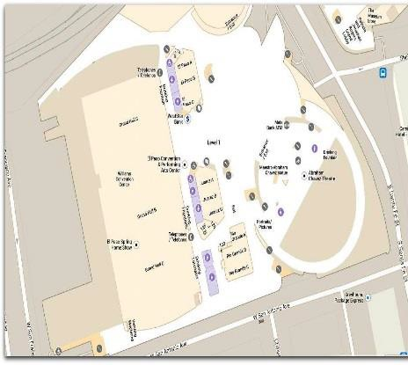

|  |  |  |  |  |  |
| --- | --- | --- | --- | --- | --- |
| **Priority 4 – Additional Access** | |  |  | **Comments** | **Possible Solutions** |
| **Drinking Fountains** *(2012 TAS Standards – Chapters 2 (204, 205 and 211), 3 (305, 306, 307, 308 and 309) and 6 (602)*) ***Note:*** If provided, fountains must comply with TAS  standards. | | | | | |
| **4.1**  **TAS**  **211.2**  **602.4**  **602.7** | Are there at least 2 drinking fountains where:  • 1 unit has a spout outlet 36”  max. above the floor finish  *and*  • 1 unit for standing persons  where the spout outlet is 38”-  43” max. above the floor finish  ***211.2 Exception:*** Where a single drinking fountain complies with 602.1 through 602.6 and 602.7, it shall be permitted to be substituted for two separate drinking fountains. | □Yes □No □N/A  Spout Measurement:  □Yes □No □N/A Spout Measurement: | Two separate drinking fountains  (1) 36” max spout and (1) 38”- 43” spout  *or*  Hi-Lo drinking fountain unit  (1) 36”max spout and (1) 38”- 43” spout | Photo #: | • Install drinking fountains that comply with both height requirements  ***Note:*** 2012 TAS no longer allows “water coolers” (bottled water dispensers) in lieu of water fountains. |
| **4.2**  **TAS**  **211.3** | When more than the minimum number of drinking fountains are provided, do 50% of the total number of fountains comply with the 36” max. spout height requirements at 602.4 and 50% of the total number of fountains comply with the 38”-43” max. height requirements at 602.7?  ***211.3 Exception:*** Where 50% of drinking fountains yield a fraction, 50% shall be permitted to be rounded up or down provided that the total number of fountains complying with 211 equals 100% of fountains | □Yes □No □N/A |  | Photo #: | • Adjust total number of fountains to comply with standards |



|  |  |  |  |  |
| --- | --- | --- | --- | --- |
| **4.3** Do drinking fountains have:  **TAS** • clear floor space in front of the  **305.3** fountain that is centered on  **306.2** the unit and is 30” wide x 48”  for a forward approach?*  • knee and toe clearance of 9”  high from floor finish and is  17”-25” deep under the  fountain? | □Yes □No □N/A  Measurement:  □Yes □No □N/A  Measurement: |  | Photo #: | • Alter space  • Replace drinking fountain  *If installed before 3/15/12, a parallel approach is permitted and the clear  floor space is not required to be centered |
| **4.4** If the drinking fountain is:  **TAS** • No deeper than 20”, are the  **205.1** operable parts no higher than  **308.2.2** 48” above the floor?  • Between 20”-25” deep, are the operable parts no higher than  44” above the floor? | □Yes □No □N/A  Measurement:  □Yes □No □N/A  Measurement: |  | Photo #: | • Adjust drinking fountain  • Replace drinking fountain |
| **4.5** Can drinking fountain controls:  **TAS** • Be operated with one hand and  **205.1** without tight grasping, pinching  **309.4** or twisting of the wrist?  • Be operated with less than 5 pounds force? |    □Yes □No □N/A  □Yes □No □N/A  Measurement: |  | Photo #: | • Change control  • Adjust control |
| **4.6** Is the spout located:  **TAS** • 15” from the rear (vertical  **205.1** support) of the fountain?  **602.5** • 5” max. from the front edge of  the unit, including bumpers? | □Yes □No □N/A  Measurement:  □Yes □No □N/A  Measurement: |  | Photo #: | • Adjust spout  • Replace drinking fountain |

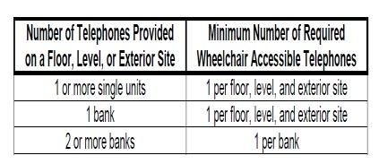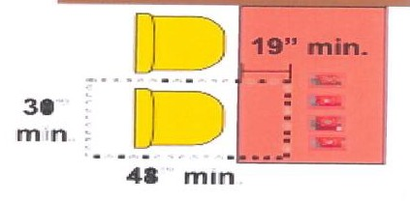

|  |  |  |  |  |
| --- | --- | --- | --- | --- |
| **4.7** Does the spout provide a flow of  **TAS** water 4” high min. that is located  **205.1** 5” max. from front of the unit?  **602.6 *Advisory 602.6:*** The flow of water should be 4” high so a cup can be inserted to provide a drink of water for an individual who, because of a disability, would other- wise be incapable of using the fountain | □Yes □No □N/A  Measurement: |  | Photo #: | • Adjust water flow of spout |
| **4.8** If the bottom/leading edge of the  **TAS** fountain is higher than 27” above  **204.1** the floor, does the front of the  **307** fountain protrude no more than  4” into the circulation path? | □Yes □No □N/A  Measurement: |  | Photo #: | • Adjust drinking fountain  • Replace drinking fountain  • Add tactile warning such as permanent planter or partial walls |
| **Public Telephones and TTYs** (*2012 TAS Standards – Chapters 2 (216 and 217), 3 (305 and 308), and 7 703 and 704))* ***Note:* TTY’s are interactive text-based communication systems** | | | | |
| **4.9** Where public telephones are  **TAS** provided, is at least one (1)  **217.2** wheelchair accessible telephone provided in accordance with the table? | □Yes □No □N/A |  | Photo #: | • Provide proper number of accessible telephones |
| **4.10** Does at least one telephone have  **TAS** a minimum clear floor space of  **217** 30” wide x 48” long for a parallel  **305.3** or forward approach**?**  **305.5** | □Yes □No □N/A  Measurement: |  | Photo #: | • Move telephone  • Install new telephone for  clear floor space |
| **4.11** Is the highest operable part of the  **TAS** telephone no higher than 48”  **217** above the floor?  **308.2.1**  **308.3.1** | □Yes □No □N/A  Measurement: |  | Photo #: | • Adjust telephone |

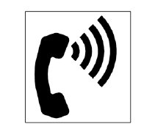

|  |  |  |  |  |
| --- | --- | --- | --- | --- |
| **4.12** If the leading (bottom) edge of  **TAS** the telephone is higher than 27”  **217** above the floor, does the front of the telephone protrude no more  4” into the circulation path? | □Yes □No □N/A  Measurement: |  | Photo #: | • Adjust telephone |
| **4.13** Do all public telephones have  **TAS** volume controls complying with  **217.3** 704.3?  **704.3 *Note:*** Public telephones must provide a volume gain adjustable up to 20 dB minimum. Amplifiers can be located in the base or handset or built into the telephone and operated by pressing a button or key. Portable and in-line  amplifiers can be used with some phones. | □Yes □No □N/A |  | Photo #: | • Install amplifier/volume  control  • Replace telephone with one that has volume control |
| **4.14** Are telephones with volume  **TAS** control identified by a pictogram  **703.7.2.3** of a telephone handset with radiating sound waves? | □Yes □No □N/A |  | Photo #: | • Add sign with pictogram |
| **NOTE: A TTY (TeleTYpewriter) or text telephone consists of a keyboard and a display screen. Separate requirements are provided for TTYs based on the type of building (public or private) and the number of public pay telephones provided at a bank of telephones, within a floor, building, or on a site. The TAS requirement at 217.4.1 states that a TTY must be provided when both public pay telephones *AND* a phone bank of four (4) or more public pay telephones are provided at a facility. However, if located in a PUBLIC building containing at least one public pay phone on a floor, a minimum of one public TTY pay phone shall be provided on that floor. As most workforce solutions offices do not utilize public pay telephones when providing services to customers (i.e., telephone services are provided free of charge), a TTY device is generally not required under TAS provisions. Accessibility standards will apply only if TTY services are provided onsite. However, if the workforce solutions (WFS) office is located in a public building, you must ascertain if public pay telephones are**  **utilized on the floor where the WFS office is located to determine applicability of TAS provisions due to the path of travel on the accessible route to the WFS**  **office. Additional note: TTY services may need to be offered as a reasonable accommodation to customers under the Americans with Disabilities Act (ADA).** | | | | |

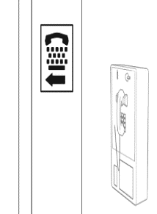

|  |  |  |  |  |
| --- | --- | --- | --- | --- |
| **4.15** Is the facility compliant with TTY  **TAS** requirements when both public  **217.4.1** pay phones *and* a phone bank of four (4) or more phones are provided? | □Yes □No □N/A |  | Photo #: | • Install TTY |
| **4.16** If located in a public building, if at  **TAS** least one public pay telephone is  **217.4.2.1** provided on a floor, is at least one  public TTY provided on that floor? | □Yes □No □N/A    |  | Photo #: | • Install TTY |
| **4.17** For TTYs required at public pay  **TAS** phones, is touch surface of TTY  **704.4.1** keypad 34” min above the floor?  ***Advisory***: While seats are not required at TTYs, if one is provided, the TTY does not have to comply with keypad height requirements. | □Yes □No □N/A  Measurement: |  | Photo #: | • Adjust height of TTY |
| **4.18** Is the public TTY identified by the  **TAS** International Symbol of TTY?  **216.9.1**  **703.7.2.2** | □Yes □No □N/A |  | Photo #: | • Add signage with symbol |
| **4.19** • Do signs providing direction to  **TAS** public pay phones also provide  **216.9.2** direction to the public TTY?  • Do signs at banks of public pay phones NOT containing a public TTY provide directional signs indicating the location of the nearest public TTY? | □Yes □No □N/A  □Yes □No □N/A |  | Photo #: | • Add signs |

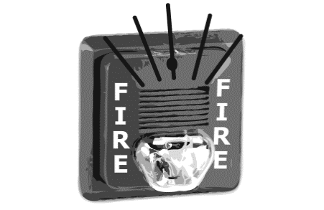

|  |  |  |  |  |
| --- | --- | --- | --- | --- |
| **Fire Alarm Systems** *(2012 TAS Standards – Chapter 7 (702))* | | | | |
| **4.20** For fire alarms at facilities:  **TAS** • Are systems permanently  **702.1** installed?  • Do systems have both flashing lights and audible signals? | □Yes □No □N/A  □Yes □No □N/A |  | Photo #: | • Install audible and visual  alarms |
| **Additional Items to Review During the Site Visit** | | | | |
| **1.** Is the WIOA EO Notice on “Equal Opportunity is the Law” (refer to Orientation to Discrimination Complaint Procedures form  for full text) posted prominently and in reasonable number and places in workforce centers and satellite offices? | | | | □Yes □No |
| **2.** Where are EO Notices posted?  •  • | | | |  |
| **3.** Are auxiliary aids (e.g., screen readers/magnifiers, telephones with volume control, large print keyboards, etc.) reported by the Board as “available upon request to individuals with disabilities” located at centers as declared? [Obtain list from EO Unit] | | | | □Yes □No |